**Ideation Phase**

**Brainstorm & Idea Prioritization Template**

|  |  |
| --- | --- |
| Date | 03 September 2022 |
| Team ID | PNT2022TMID35002 |
| Project Name | AI-Powered Nutrition Analyzer For Fitness Enthusiasts |
| Maximum Marks | 4 Marks |

**Step-1: Team Gathering, Collaboration and Select the Problem Statement**

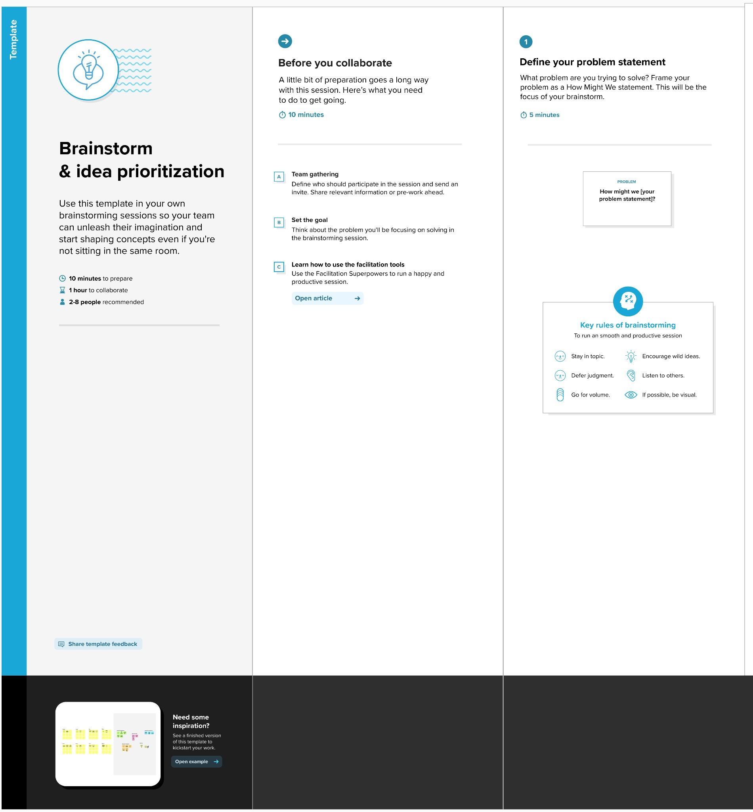

**Step-2: Brainstorm, Idea Listing and Grouping**

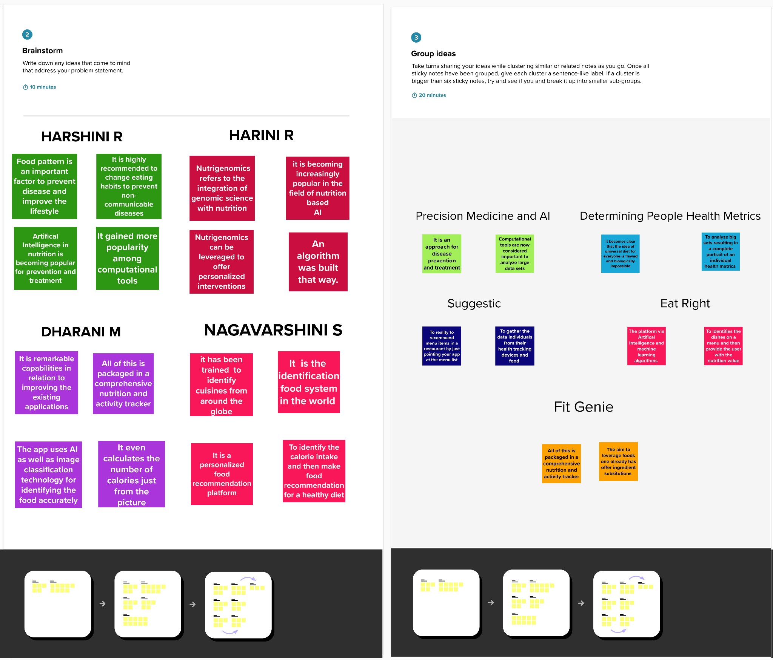

DENISHAANGEL

MERSHEENA

CATHRINRISMA

MARY ASHMI

Step-3: Idea Prioritization

